## Lab Program 1:

## Aim:

1. Display Sales across different years in different categories using Area chart for given sample Super sales data set.

## Steps:

1. Connect to "Sample - Superstore".

2. Drag "Year of Order Date" to Columns, "SUM(Sales)" to Rows (area chart).

3. Optional: Filter by Category, format axes, add titles.

4. Save (.twb).

## Output:

## 

## Aim:

1. Display sales information for departments across various regions.

## Steps:

1. Connect to "Sample - Superstore".

2. Drag "Region and category " (Columns) , "SUM(Sales)" (Rows - bar chart).

3. Save (.twb).

## Output:

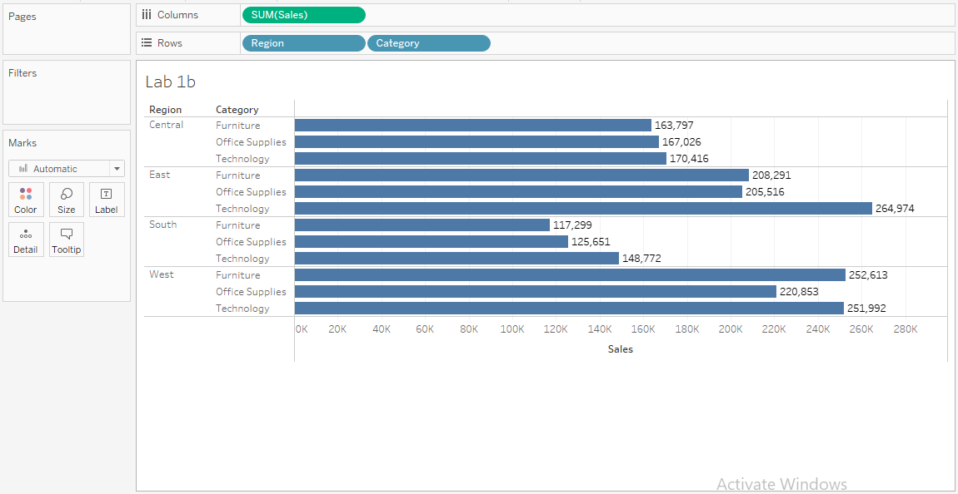

## Aim:

1. Demonstrate stacked Bar chart in Tableau

## Steps:

1. Connect to "Sample - Superstore".

2. Drag "SUM(Profit) and SUM(sales)" to Rows (stacked bar chart).

3. Color by "YEAR(Order date)" (shows profit breakdown by year).

4. Save (.twb).

## Output:

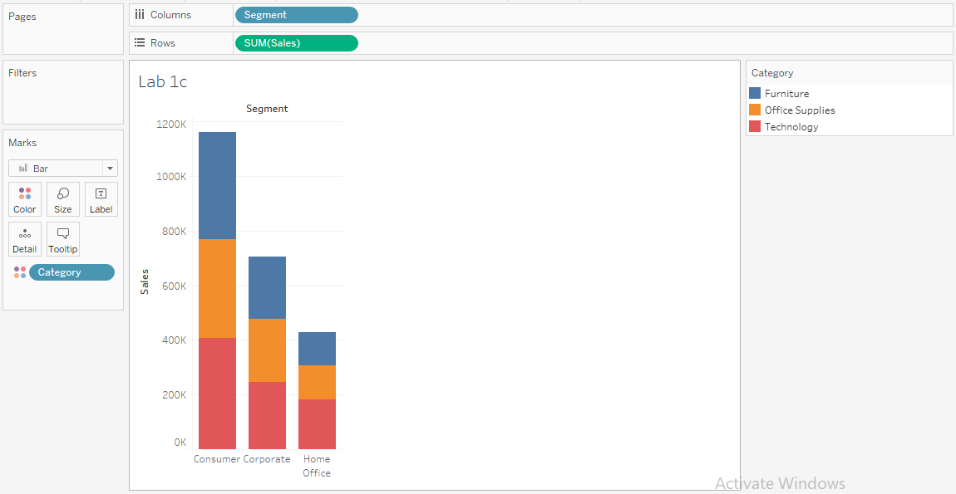

## Lab Program 2:

## Aim:

## Display total sales based on category over the years. [Filters]

## Steps:

## 1. Category and sales drag on ROWS

## 2. Order date on Columns

## 3. Now filter the data based on order date :

## 1. Order date is placed on the filter shelf

## 2. Click range of dates

## 1. Relative dates

## 1. Years

## Output:

## 

## Aim:

1. In Bar graph how has profit change over the time (Year) by region?

## Steps:

1. Connect to "Sample - Superstore".

2. Drag “Region and SUM(Profit)”(Rows) , “YEAR(Order Date)” (Columns).

3. Color by YEAR(Order Date).

4. Save(.twb)

## Output:

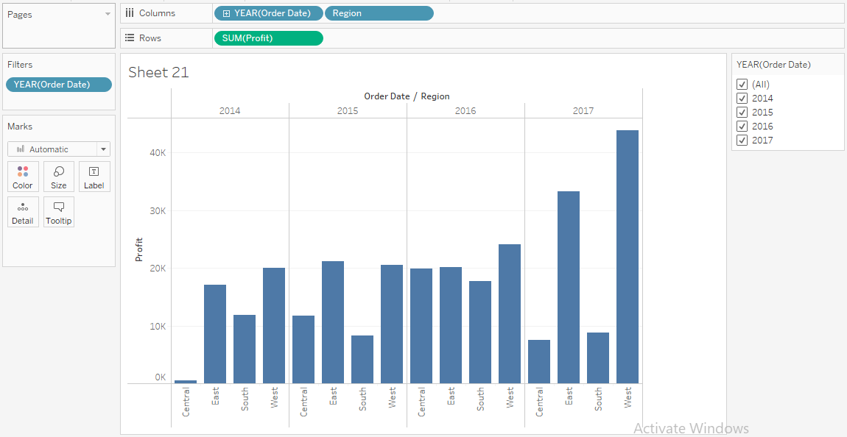

## Aim:

1. By using the Sample Super Store Find the top 5 sub category of products for category called Furniture.

## Steps:

1. Connect to "Sample - Superstore".

2. Drag "Sub-Category" to Rows, "Sales" to Columns. Filter "Category" to "Furniture" using

context filter.

3. On Filter , click down arrow next to "Sub-Category" > Top > Top N.

o Set "Top" to desired number (e.g., 5).

o Set "Sort" to "Descending".

4. save (.twb)

## Output:

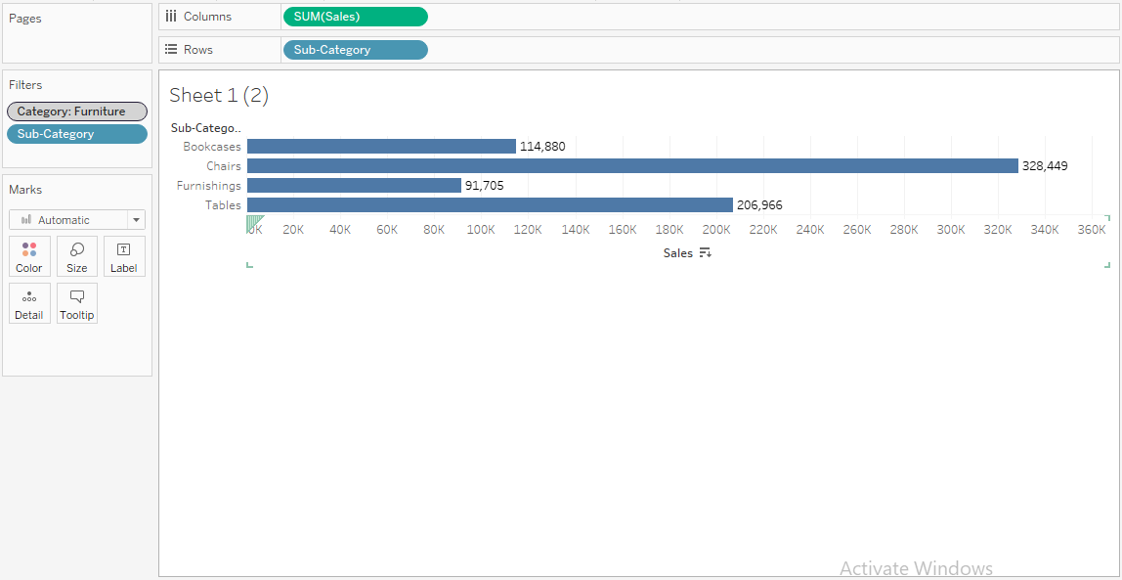

## Aim:

1. Find Sub category of products across all segments whose sales exceed one million.

## Steps:

1. Connect to "Sample - Superstore".

2. Drag "Segment and SUM(Sales)" to Columns, "SUM(Sales)" to Rows (Bar chart).

3. Filter on Sub-Category ->Condition Filter-> (sales >1 Million).

4. “Sub-Category” on text.

5. Save (.twb).

## Output:

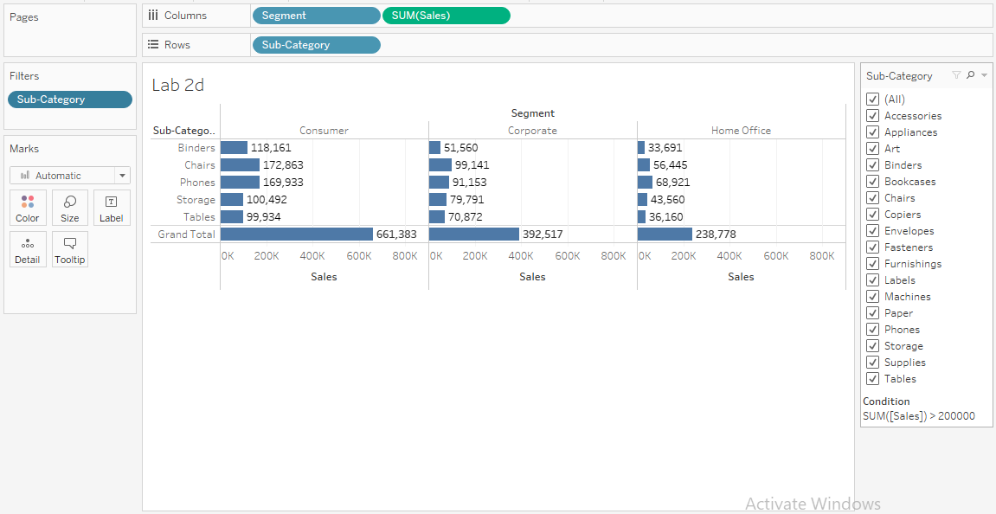

## Lab Program 3:

## Aim:

1. Display % of total sales in category wise in both Cross table and Bar graph [Quick Table Calculation]

## Steps:

1. Drag category on columns
2. Sales on rows
3. Now on Rows Sum(sales) right click and 🡪 Quick table calculation 🡪 percentage of total
4. Click on T in tool bar

## Output:

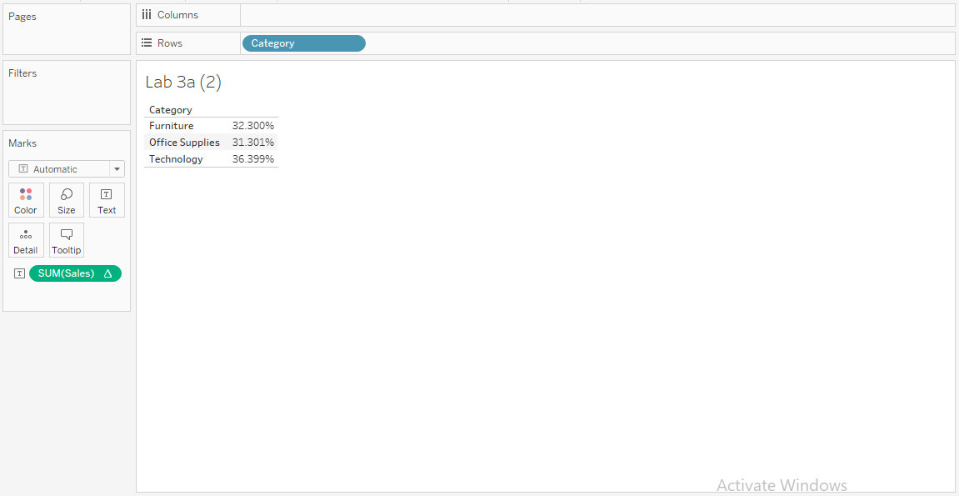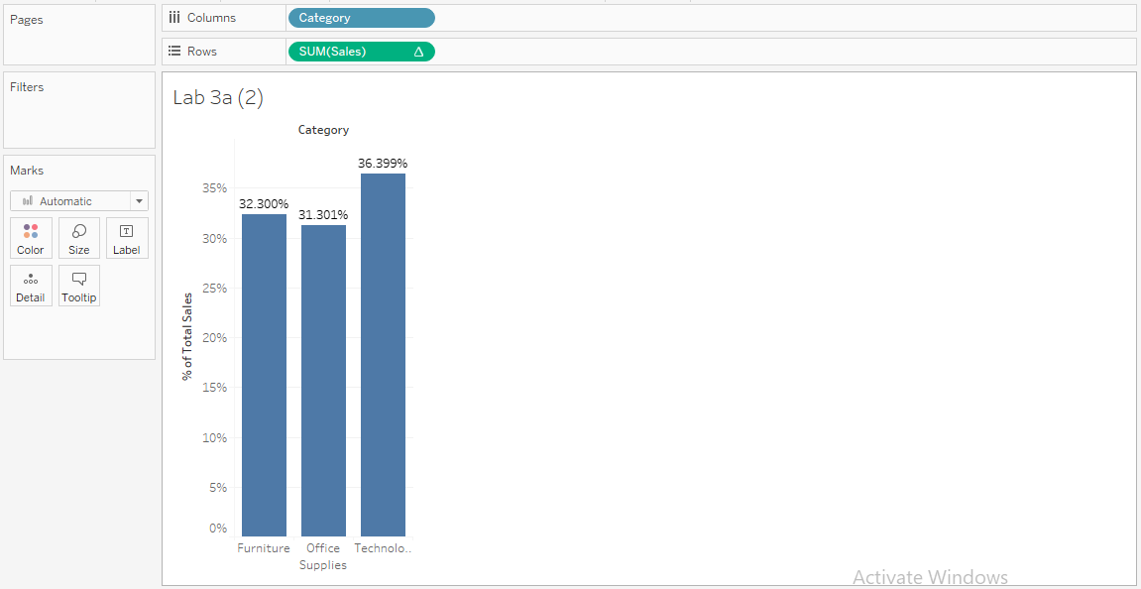Aim

## Aim:

1. Display total sales based on order date as well as % of total sales Based on order date.

## Steps:

1. Drag Order Date on columns
2. Sales on rows two times
3. Now on Rows Sum(sales) right click and 🡪 Quick table calculation 🡪 percentage of total
4. Click on T in tool bar

## Output:

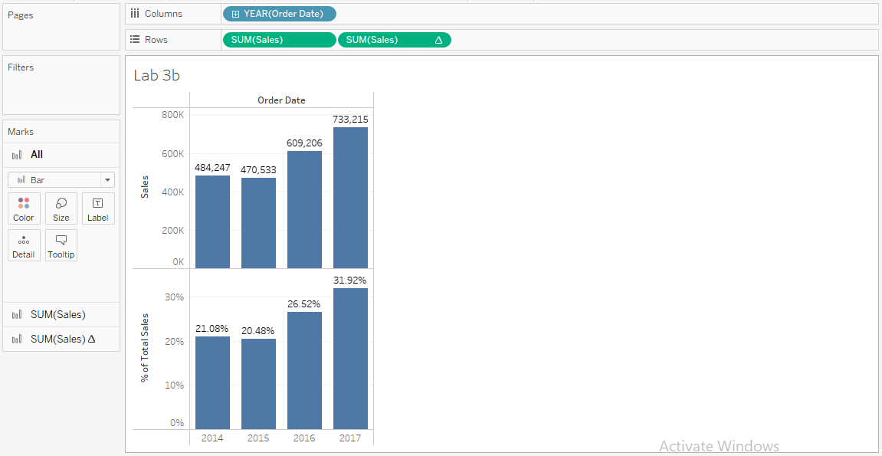

**Aim:**

1. Calculate % sales category and subcategory wise in cross tab and Also display Grand total as well as total forEach category.

**Steps:**

1. Connect to "Sample - Superstore".

2. Drag "Category and Sub-Category to Rows (Cross Table).

3. Sales on Text

4. Want to see % of total sales Right click on sales in Marks card and Choose Quick table

calculation Percentage of total.

5. Save (.twb).

**Output:**

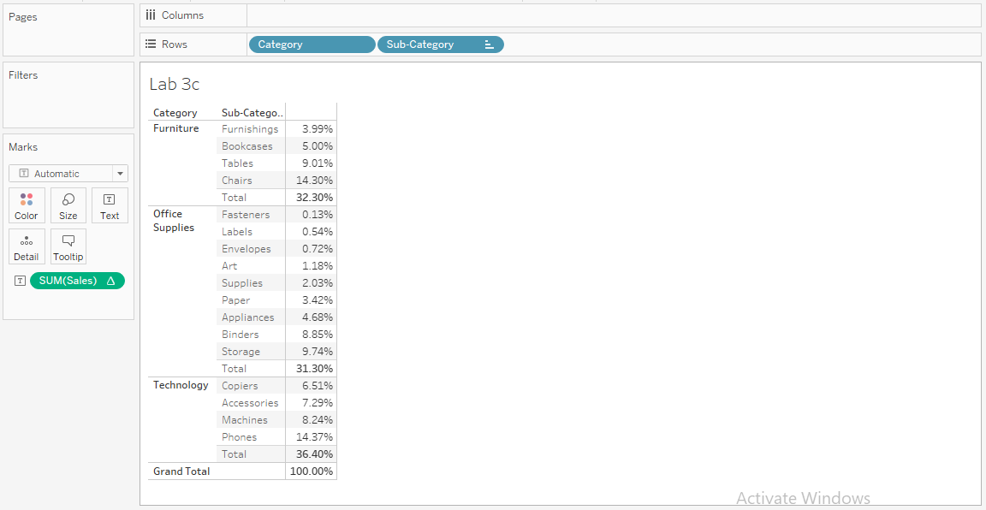

## Aim:

1. Calculate the running total of sales based on order date

## Steps:

In cross table

1. Connect to "Sample - Superstore".

2. Order date on Row

3. Sales on text

4. Get sales on Month wise by click on +

5. Put sales on Row and convert it into discrete

6. In order to get cumulative addition click on quick table calculation and choose Running

total.

7. Save(.twb)

## Output:

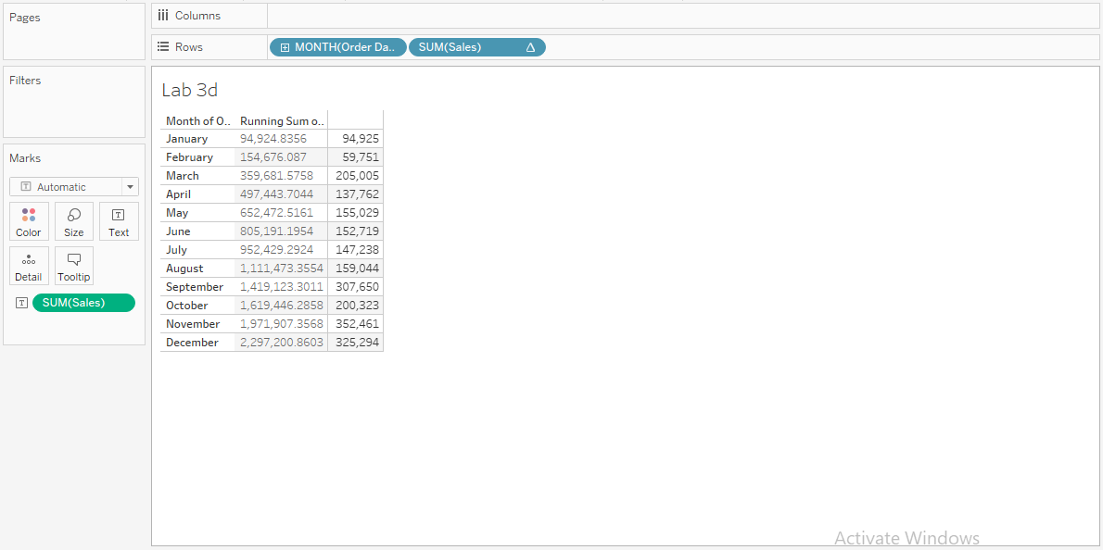

**Lab Program 4:**

**Aim:**

1. Find out the profit coming from the customers whose first name is “Bryan”. [Table Calculation]

**Steps:**

1. Connect to "Sample - Superstore".

2. Drag "Customer Name" to Columns , “SUM(Profit)" to Rows.

3. Using Table Calculation

4. Save (.twb).

**Output:**

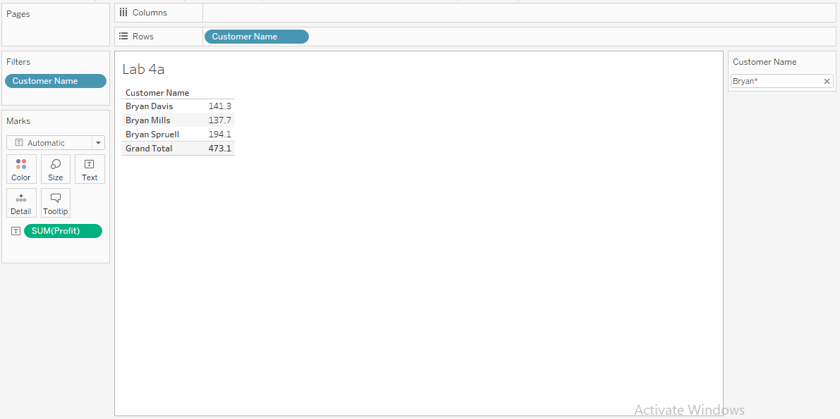

**Aim:**

1. Find out the difference in order date and ship date to know the average no. of days taken to ship an order placed.

**Steps:**

**Output:**

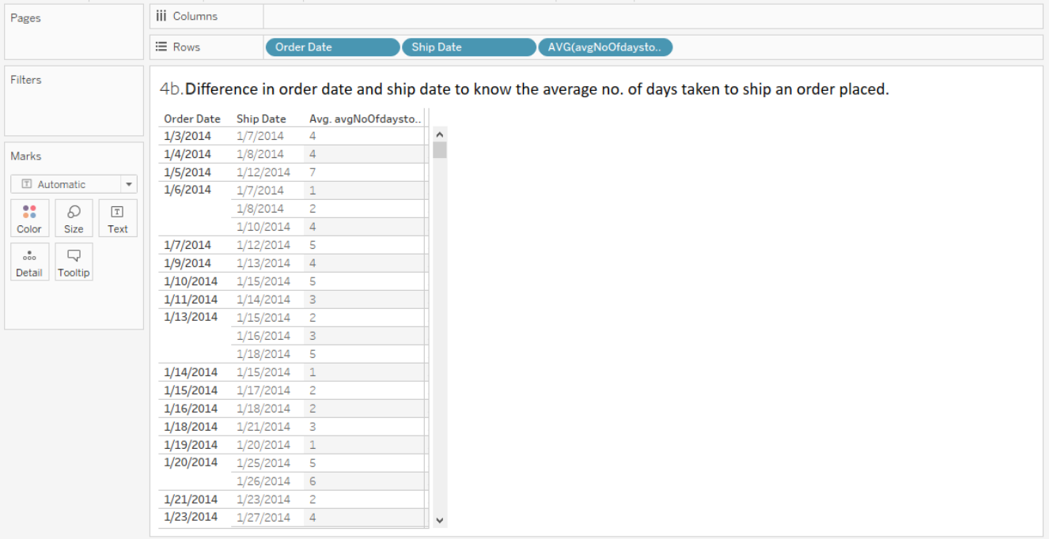

## Aim:

1. Calculate Profit Sale Ratio of products subcategories within different states.

## Steps:

1.Steps to Create Calculated Fields:

• Drag and Drop State into the column shelf

• Drag and Drop Category and Sub-Category into the row shelf.

2.Create Calculated Field

• Select Analysis -> Select Create Calculated Field

• Enter the name Profit-Sale Ratio

• Enter the Formula

IIF ([Sales]!=0,[Profit]/[Sales],0)

Note: The above formula:

Checks Sales is not equal to zero

If True, return Profit ratio ([Profit]/[Sales])

If False returns 0

Click OK

New Calculated Field Profit-Sale Ratio is added in the Data Pane

Drag and Drop Profit-Sale Ratio on the Mark Card

## Output:

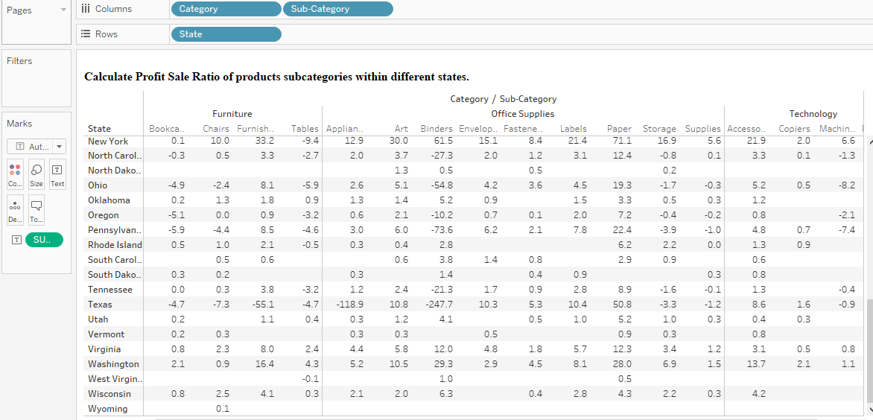

## Lab Program 5:

## Aim:

1. Using the sample superstore data, find what percent of East region sales came from “consumer” segment in the year 2017?

## Steps:

1. Connect to "Sample - Superstore".

2. Drag "SUM(Sales)" to Rows, "YEAR(Order Date)" to Columns.

3. Filter "Region" to "East" and “YEAR(Order Date)” to “2017”and set them to Context

filter.

4. “Segment” to Color.

5. save (.twb).

## Output:

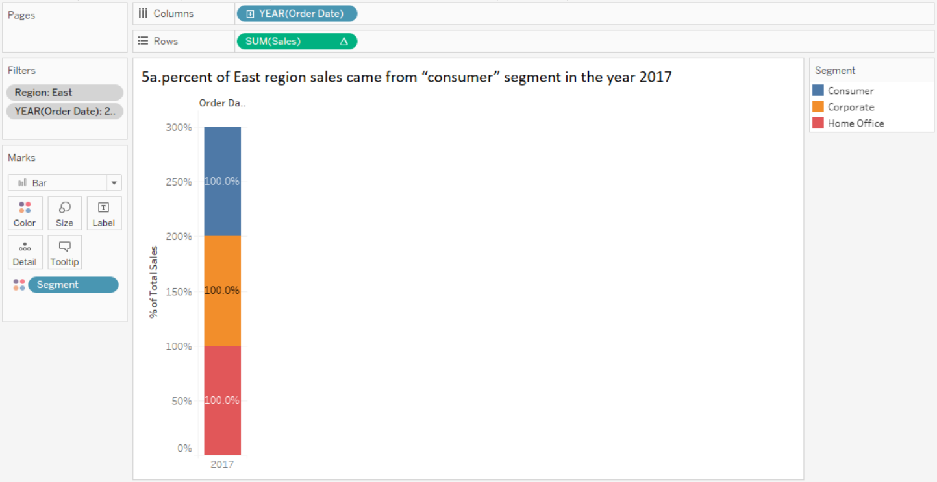

## Aim:

1. Find which product is ranked 6th in sales for west region?

## Steps:

1. Connect to "Sample - Superstore".

2. Drag "SUM(Sales)", to Rows, "YEAR(Order Date)" to Columns.

3. Filter "Region" to "west" using Context filter and “Product Name ” to Top N (.ex,6) based

on SUM(Sales) .

o Set "Sort" to "Descending".

4. “Segment” to Color.

5. save (.twb)

## Output:

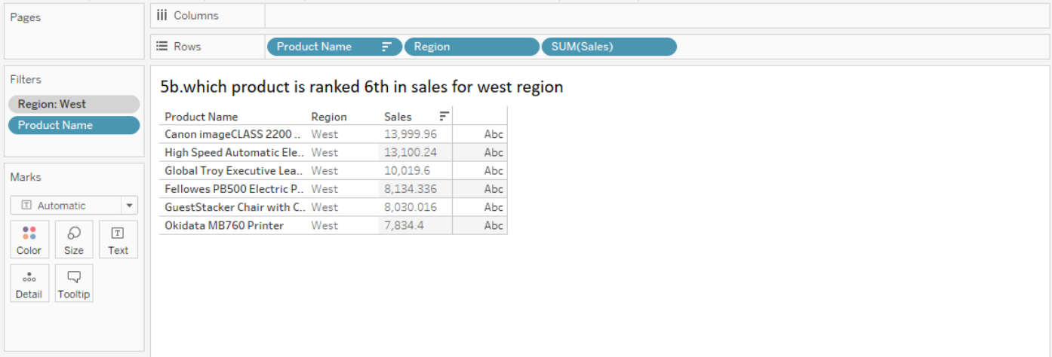

## Aim:

## Compute the % growth in sales between June 2015 and June 2017

## Steps:

## Output:

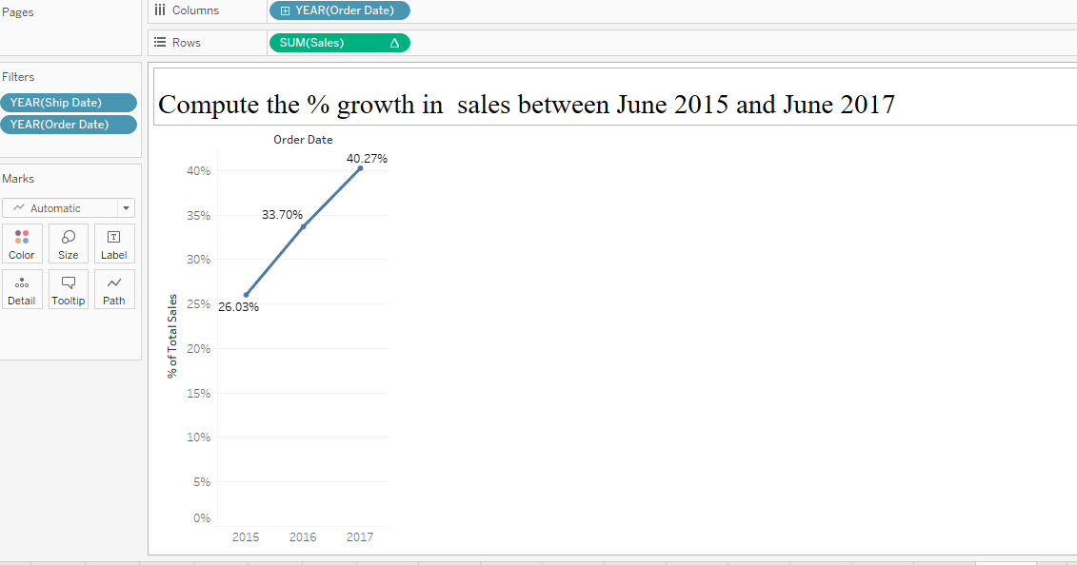

## Lab Program 6:

## Aim:

1. Find the amount of Sales for each state in each region. [LOD Expression]

## Steps:

## Output:

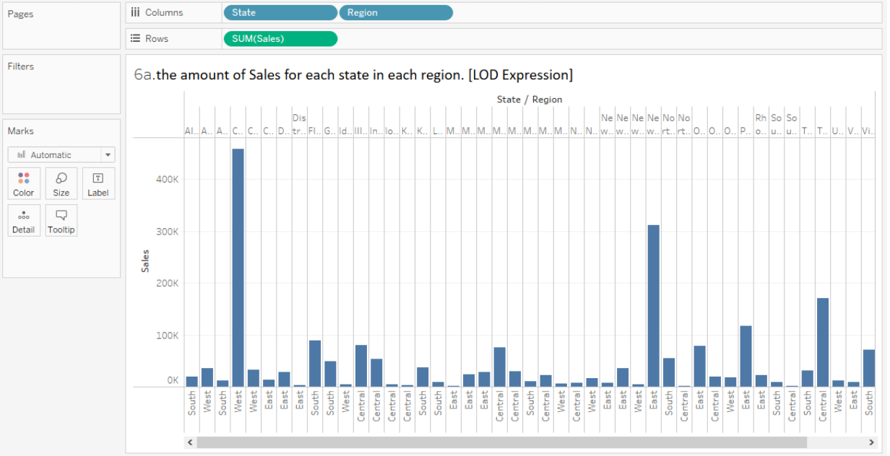

## Aim:

1. Calculate the sum of sales per state for each sub-category of products.

## Steps:

## Output:

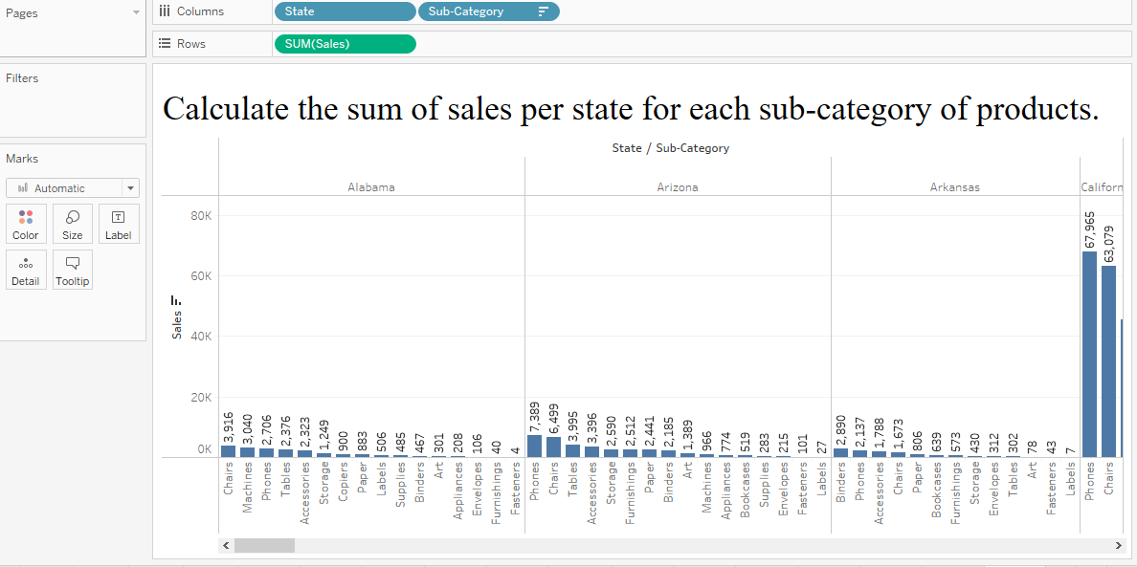

## Aim:

## Calculate the average regional profit for each category.

## Steps:

## Output:

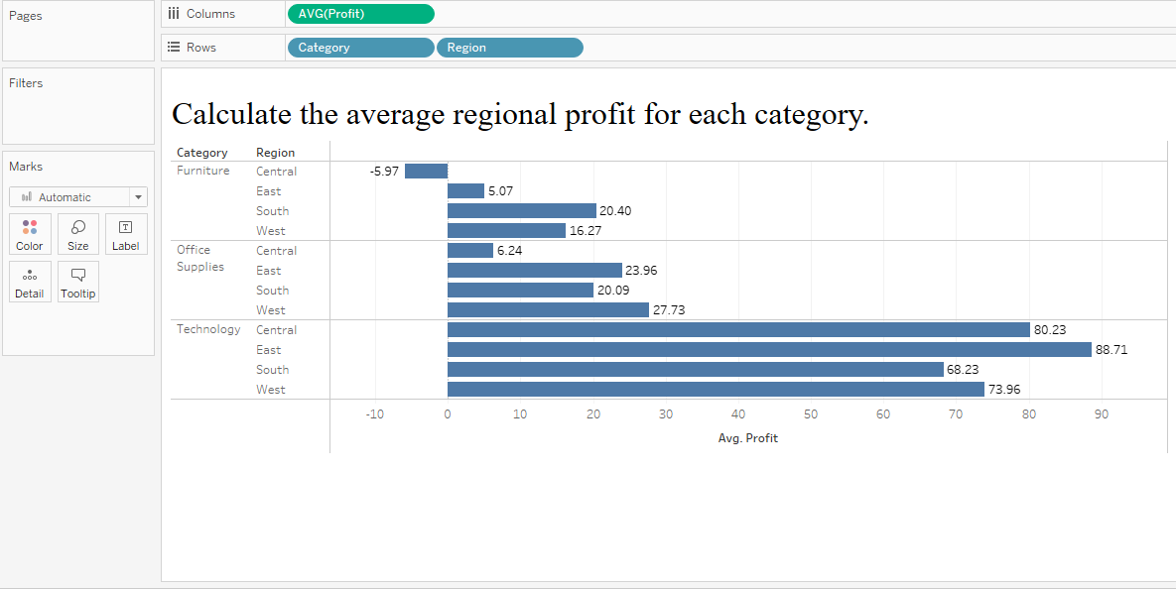

## Lab Program 7:

## Aim:

## How to change date level in Tableau using parameter.

## Steps:

## 1. Connect to "Sample - Superstore".

## 2. Create parameter name it as new-date {datatype: string values: day, month, year}

## 3. Noe create calculated field as new-date Cal with following formula

## CASE [new-date]

## when 'day' then DATETRUNC('day',[Order Date])

## when 'month' then DATETRUNC('month',[Order Date])

## when 'year' then DATETRUNC('year',[Order Date])

## End

## 3. Now drag new-date cal on columns

## 4. Now right click on parameter and choose show parameter

## 5. Now write click on new-date-cal in columns and select exact date

## 6.save(.twb)

## Output:

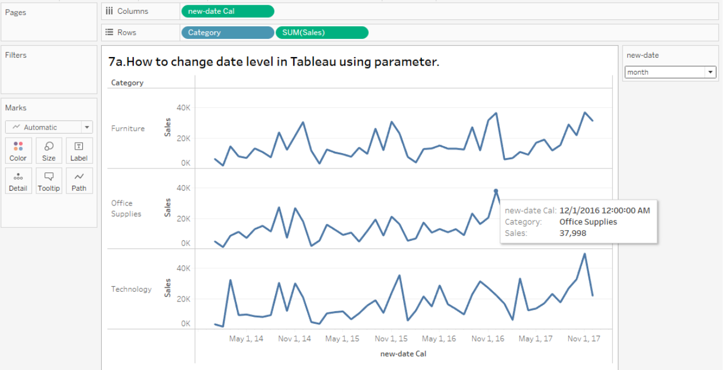

## Aim:

1. How do we use dynamic measures with multiple number formats in Tableau?

## Steps:

1: Connect to data

→ In Tableau Desktop, connect to Tableau: Sample Superstore

2: Create the visualization

→ Create a Parameter: Measure

Data type: Integer

List of values – Display As

1 – Sales

2 – Qty

3 – Profit Ratio

→ Create a Calculated field: Dynamic Measure

CASE [Measure]

WHEN 1 THEN sum([Sales])

WHEN 2 THEN sum([Quantity])

WHEN 3 then sum([Profit])/sum([Sales])*100

END

→ Create a Calculated field: Prefix

CASE [Measure]

WHEN 1 THEN ‘$’

WHEN 2 THEN ”

WHEN 3 THEN ”

END

→ Create a Calculated field: Sufix

CASE [Measure]

WHEN 1 THEN ”

WHEN 2 THEN ‘ q’

WHEN 3 THEN ‘%’

END

→ Drag Dynamic Measure on Columns

→ Drag Category and Sub-category on Rows

→ Drag Dynamic Measure, Prefix and Sufix on Text

→ Click on Label and edit text: <Prefix ><AGG(Dynamic Measure)><Sufix>

3:Save(.twb)

## Output:

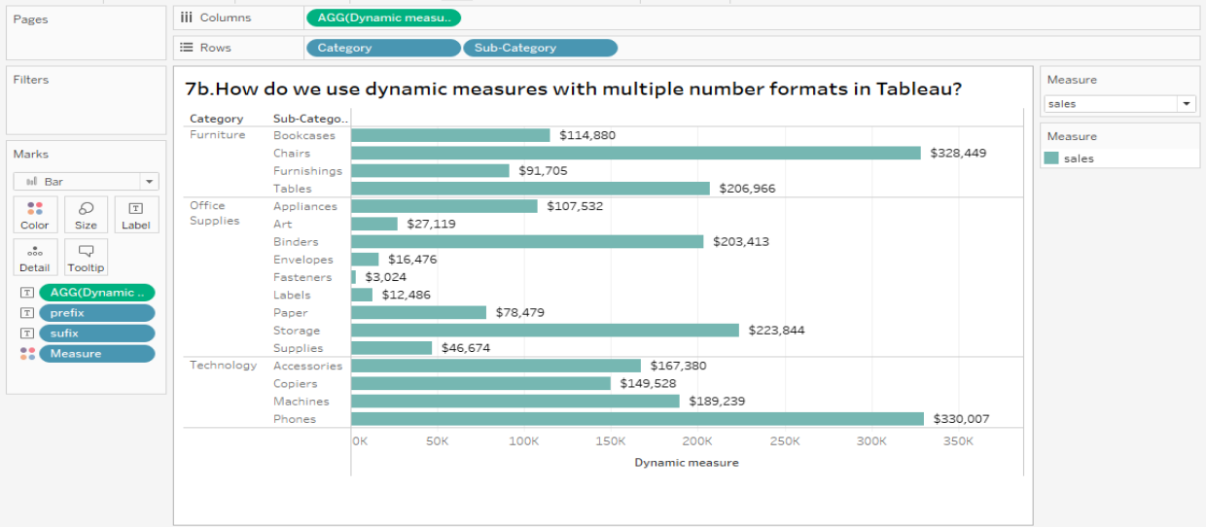

## Lab Program 8:

## Aim: Demonstrate advantage of Reference lines in tableau.

## Steps:

1. Connect to "Sample - Superstore".

2. Before creating the parameter, let’s build a quick

chart adding Subcategory onto Columns and Sales onto Rows.

3. Now for the parameter, let's follow these steps.

a. Click the arrow next to the field search bar, and select Create Parameter.

b. Name the parameter “Para Subcategory Target.”

c. Change the data type to Integer.

d. Change the current value to 5,000.

e. Click OK.

4. When click OK, a new section in the calculated field pane appears, named “Parameters.” In

that list, we should see the Para Subcategory Target.

5. If we right-click on the parameter and select Show Parameter, the parameter control section

appears on the left.

6. It will produce a box that looks similar to the filter, with the title “Para Subcategory Target”

and the value 5000.

7. Let’s add this parameter to the chart.

a. At the top of the field list there’s an option to change the pane to “Analytics.”

b. In the Analytics pane, drag a reference line onto the chart.

c. For Value select from parameter and pick the Para Subcategory Target.

8. Click fill below, and select red.

9. With this, we have a dynamic target, and we can easily see which subcategories are

underperforming.

10. Save(.twb)

## Output:

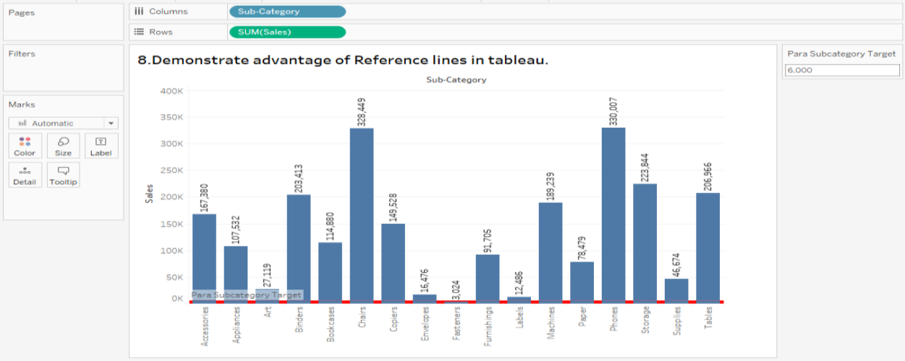

**Lab Program 9:**

**Aim:** Using the Sample-superstore, create a dashboard showing the sales and profits for different segments and Sub-Category of products across all the states.

**Steps:**

**Output:**

**Lab Program 10:**

**Aim:** Create interactive dashboard using the Sample-Superstore.

## Steps:

## Output:

